Ticketing Systems

Ticketing systems:is a software used to track, manage and reslove inquries compliants or techical issues for people working in IT Roles

- Creating ticket using jira service management
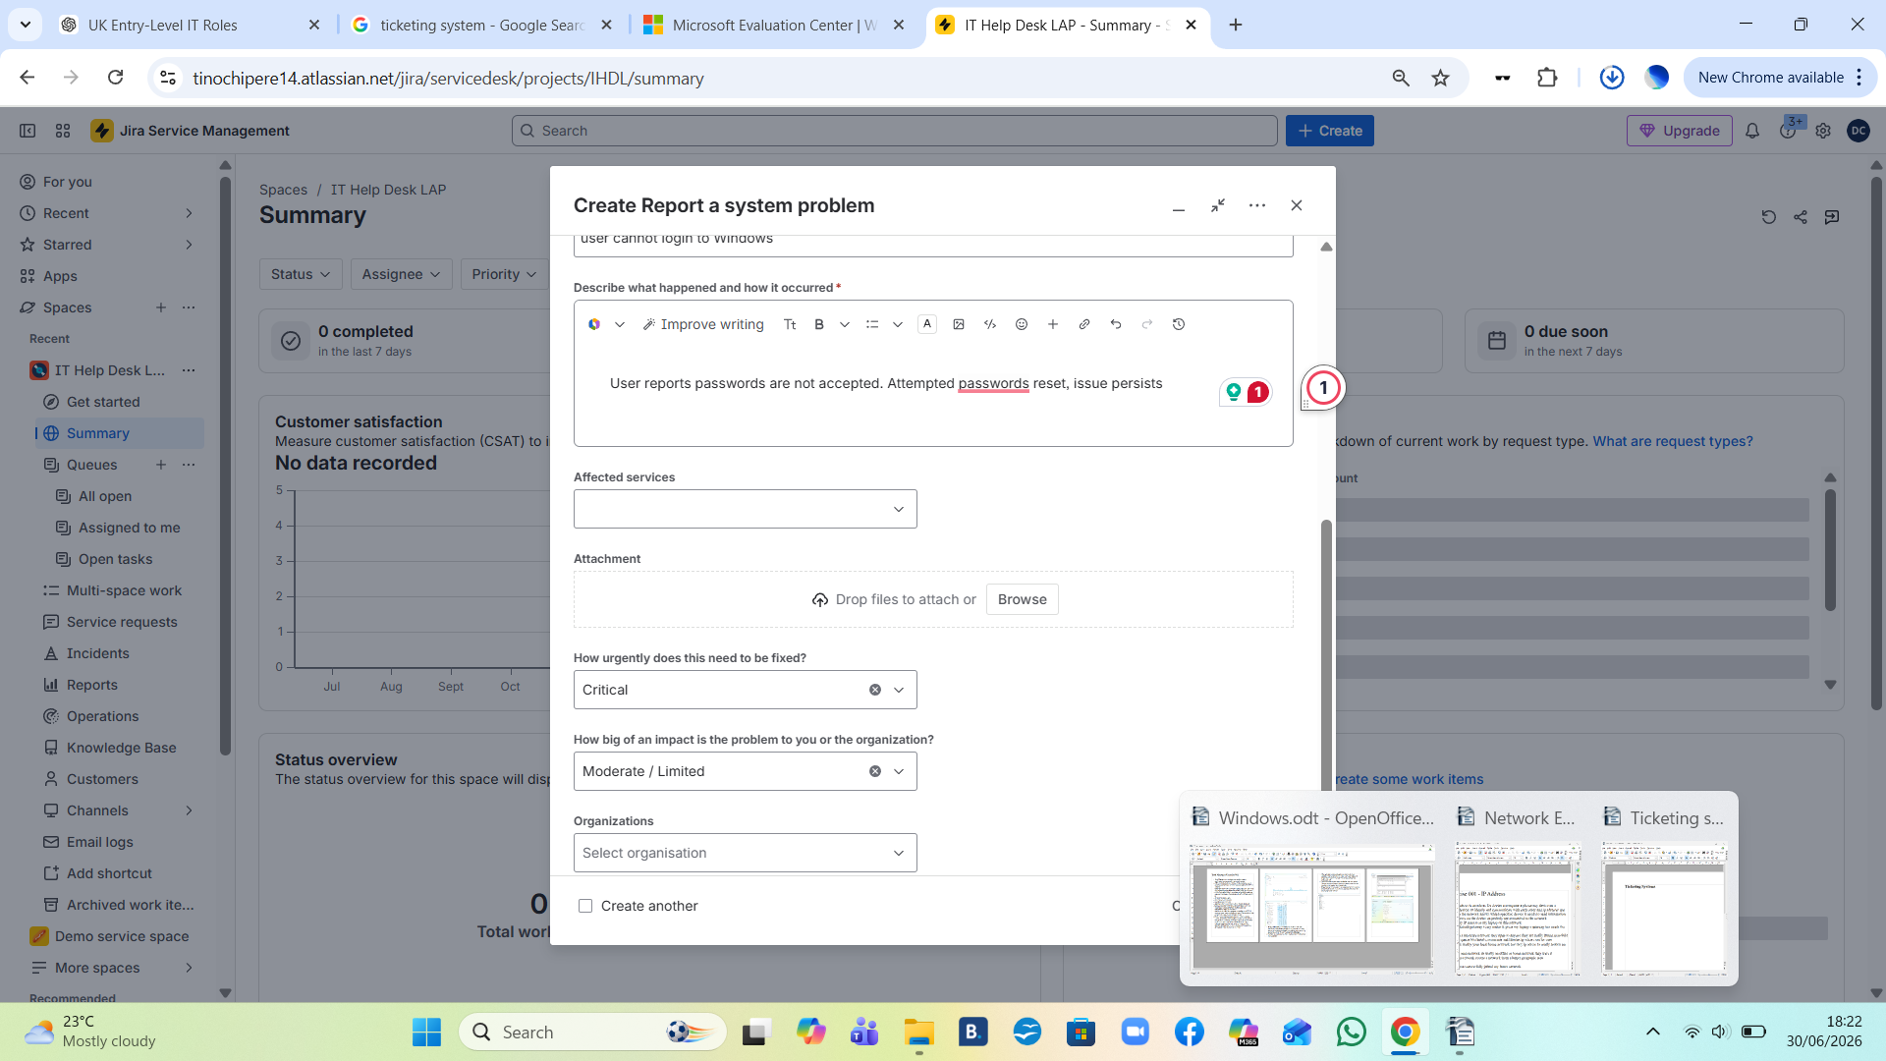
- adding notes
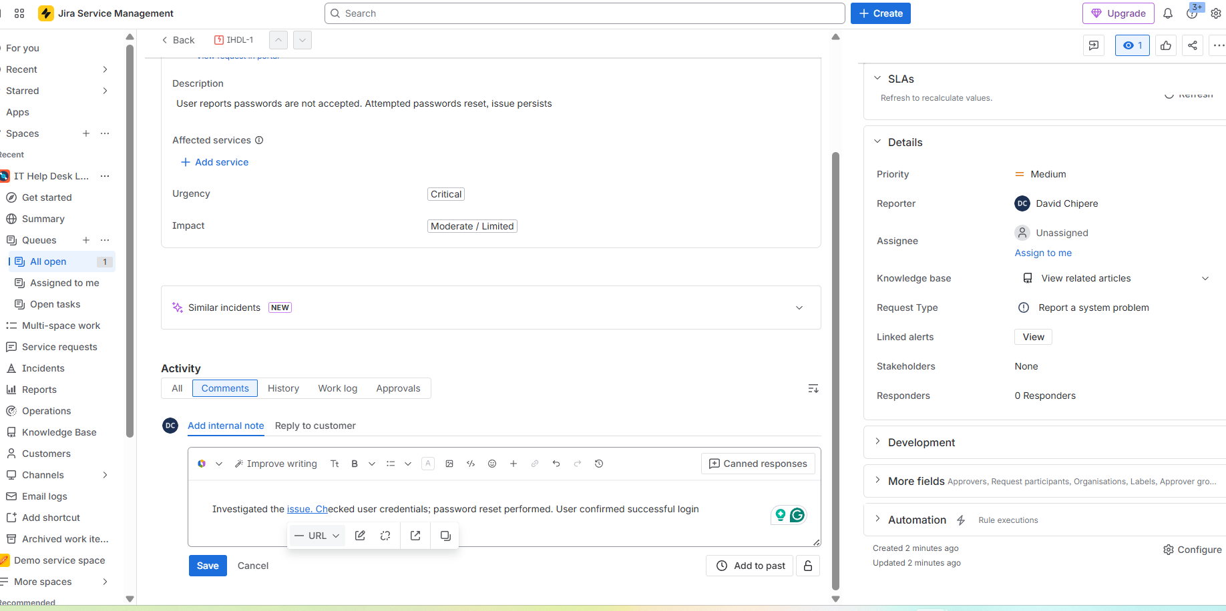
3. More Incidents that need to be resolved
